
UNIVERSITY OF HERTFORDSHIRE
School of Physics, Engineering and Computer Science
MSc Title
Module Code and Title
Date: 14/07/2025
Vehicle Price Prediction Based on Features

Name: Ghamees Ul-Mohsin
ID: 22070997
Prof: Kufreh Sampson

Abstract
The swift growth of the automotive industry, combined with increasing consumer demand, has a significant impact on the expansion of the second-hand vehicle market. However, this flow has also empowered sellers to raise prices. It creates a need for transparent and data-driven vehicle evaluation. This project aims to develop a machine learning-based pricing model to predict the value of used vehicles based on their structures and previous market data. Various supervised regression algorithms have been used to study the effectiveness of each model in estimating the price of vehicles. By using Linear Regression, Decision Tree, Gradient Boosting, Support Vector Regression, and Random Forest, a structured dataset has been created that contains attributes such as vehicle model, mileage, fuel type, and transmission to analyze the performance of multiple models. The performance of these models is compared using standard evaluation metrics to classify the most precise and reliable methodology. The results reveal that while all models propose reasonable predictions, ensemble methods largely offer superior performance. This work aims to enhance price transparency in the used car market, supporting better policymaking for both buyers and sellers. To make this model easily accessible to a wide-scale audience, it will be incorporated into a user-friendly website where users can input vehicle details and instantly receive an estimated market price. The website is designed to be simple and accessible for both buyers and sellers, promoting transparency and informed decision-making in the used car market.

Table of Contents
Abstract 2
List of Figures 5
Chapter 01: Introduction to the Project 5
1.1 Background 5
1.2 Problem Statement 7
1.3 Project Aim 8
1.4 Objectives 8
1.5 Project Scope 8
1.6 Project significance 8
1.7 Structure of the Report 9
Chapter 2: Literature Review 9
2.1 Introduction to Literature Review 9
2.2 Price prediction of a vehicle: Conventional vs Deep Learning-based 11
2.3 Vehicle Price Regression Models 14
2.3.1 Linear Regression 14
2.3.2 Regression by Decision Tree 14
2.3.3 Support Vector Regression (SVR) 14
2.3.4 Random Forest Regression 15
2.3.5 Gradient Boosting Regression 15
2.4 Feature Engineering and Dataset Characteristics 16
2.4.1 Profile of the Dataset 16
2.4.2 Data Cleaning and Preprocessing 17
2.4.3 Coding of Categorical Variables 17
2.4.4 Scaling the features 17
2.4.5 Selection of features: 18
Section 2.5: Evaluation Metrics 18
2.6 Web-Based Applications for Predictive Modeling 18
2.7 Category of Research Gaps 20
2.7.1 Limited Comparative Analysis of Models: 20
2.7.2 Mismatched Measurement System in Different Studies: 20
2.7.3 Little Attention to the Effect of Feature Engineering: 20
2.7.4 Ensemble Techniques underutilization: 21
2.7.5 Lapses in Real-Life Deployment and Availability: 21
2.7.6 Cross-Market Generalization: 21
2.7.7 Explainability and Trust in Forecasts: 21
2.8 Summary 21
Chapter 03: Methodology 23
3.1 Introduction to Methodology 23
3.2 Research design 23
3.3 Description of the dataset 23
3.4 Project Workflow 24
3.5 Preprocessing Data 24
3.6 Exploratory Data Analysis (EDA) 24
3.7 Models of Machine Learning 25
3.7.1 Modeling with Traditional Machine Learning 25
3.7.2 Deep-Learning Models 25
3.8 Evaluation Metrics 25
3.9 Model Comparison and Selection 25
3.10 Streamlit Deployment 26
3.11 Tools and Technologies 26
Chapter 04: Expected Results and Discussion 28
4.2 Initial Progress 28
4.2.1 Dataset Loading and Initial Exploration 28
4.2.2 Exploratory Data Analysis (EDA) 30
4.3 Early Observations 33
4.4 Expected Results from Model Training 33
4.5 Expected Deployment Result 34
4.6 Potential Challenges 34
4.7 Summary 34
Chapter 05: Conclusion 35
References 37

List of Figures
Figure 1 Used Cars Demographics Global Market Report (“Used Cars Market Report 2025 - Used Cars Industry and Share,” n.d.) 10
Figure 2 Data-Driven Pricing Outperforms Traditional Methods 13
Figure 3 Fitted line plot of car prices (“ Fitted line plot of car prices against car mileage.,” 2025.) 15
Figure 4 Project Methodology Flowchart 24
Figure 5 Dataset Loading and Display in Python 29
Figure 6 Dataset Shape and Missing Values 29
Figure 7 Checked Datatypes 30
Figure 8 Distribution of Used Car Prices 30
Figure 9 Average Price by Brand 31
Figure 10 Transmission Type Count 32
Figure 11 Mileage vs Price 32

Chapter 01: Introduction to the Project

Background
The car industry has gone through incredible development in the last couple of decades, depending on a tremendous growth in technology, the expanding urban population, as well as consumer demands. The burgeoning need for personal transport keeps increasing with the increasing affordability of vehicle ownership, particularly in developing economies. In proportion to the increase in the market with new cars, there is a marked rise in the second-hand vehicle industry, which has now become a critical part of the automobile ecosystem (Manuguerra et al., 2024). To most consumers (including those purchasing a car for the first time or those with low budgets), a used car can be a cheaper option as compared to purchasing brand-new. Along with this increased demand, however, there is a complex of difficulties. The inconsistent and even non-transparent pricing of used cars may be regarded as one of the most critical issues. The value of secondhand cars is contrary to the case with the purchase of new cars which is accompanied by a manufacturer-suggested retail price (MSRP). These can comprise the miles, the model year, and history of maintenance, the history of accidents, the type of fuel, the brand image as well as the geographical location of the seller. This has led to a situation where the prices of secondhand cars differ widely among the various sellers, thus leaving the purchase group in a state of ignorance (Das et al., 2024).
Old methods of vehicle value analysis tend to depend on human intuition, past experiences or the general trend in the marketplace. Although these methods may work, they are not precise, and they can be biased. Lack of a coherent and systematic pricing system that is driven by facts not only inhibits the decision-making process amongst consumers but also causes a loss of confidence in the used car market. Machine learning brings with it an opportunity in this kind of situation (Thu et al., 2025). The algorithm and program of machine learning, especially those involving regression analysis, provide the capacity to analyze a massive amount of sales data in the past and determine the patterns in prices. Using a wide range of different data that has all the characteristics of a vehicle and its sale price, one can accurately estimate the value of a used car. Moreover, the democratization of reliable pricing information via the incorporation of such models into user-friendly platforms can enable both the buyers and the sellers to make informed decisions and choices. This project can be managed in terms of increasing the need for transparency and fairness in the used car market. It tries to reconcile the loss between the needs and complexity of data science to everyday consumer with its development of a machine learning-based pricing model that is accurate and simple. By implementing this model on a web-based platform, users will be enabled to enter simple information about a vehicle and obtain a credible assessment of its price that will add more trust, confidence and effectiveness into the vehicle resale ecosystem (Zuo et al., 2024).

1.2 Problem Statement
The second-hand auto industry is a very crucial sector in the automotive industry, as cheap mobility solutions are provided to large mass of customers through it. Nonetheless, the absence of a standard and transparent pricing mechanism has become one of the most burning and nagging challenges in this market. In contrast to new cars, the prices of which are set by manufacturers and are not too different in different locations, the price of used cars is conditioned by a great number of factors, some of which can be measured and some others which are more subjective.
This is very fluctuating and thus becomes challenging for buyers with respect to knowing whether he is getting a good deal or otherwise. Meanwhile, sellers might not be able to provide a logical background to their asking prices or might underprice their vehicles as they can hardly rely on benchmarking. Lack of a consistent pricing framework gives rise to inefficiency in a market, decreases consumer confidence, and raises the possibility of prejudiced and ill-informed decision-making (AMBUR and Ahmed, 2025).
Online listings and pricing guides provide limited information but mostly use fixed price bands or broad valuations that do not take into consideration the custom elements of individual cars. In addition, these tools are hardly real-time data-driven and do not relay predictive information on current market dynamics. As there is access to large-scale historical data of vehicle sales and the current development of the technique of machine learning, there is the possibility explained by the discussion of the creation of a predictive model capable of giving real-time price estimation to used cars on an accurate and fair basis. The issue is how best to utilize this data by exploiting the possibilities of suitable algorithms, choosing significant features and developing a solution that can be used by non-technical users (Abu Ghareebaih, 2025).
This project will fill this gap by creating a machine learning based pricing model which not only will be able to perform better in terms of the accuracy of the used vehicle valuation, but also it will have to be more transparent and user-friendly to the average consumer since it requires no more than access to the simple web interface. By so doing, it aims at enhancing equity and efficiency of both sides of the market (both buyers and sellers) to the used cars market.

1.3 Project Aim
The main objective of the project is to come up with a machine learning-based model that will enable the prediction of the market value of used cars. Through historical data on sales and various specific features of a vehicle, the project aims to offer a reasonable, transparent, and standard measurement tool to stakeholders involved in the second-hand car trading business.

1.4 Objectives
To accomplish this goal, the project has the following objectives:
- Comparing and implementing different machine and deep learning models such as Linear Regression, Decision Tree, Support Vector Regression, Gradient Boosting, Random Forest, CNN, RNN and LSTM.
- To determine the performance of these models in terms of standard regression measures like Mean Absolute Error (MAE), Mean Squared Error (MSE), and R-squared.
- To obtain the most dependable and trusted model for predicting the price.
- To implement the optimal one into a simple-to-use website where users enter car information and get an immediate price quotation.

1.5 Project Scope
The type of data that is explored in this project has been narrowed down to second-hand vehicles and the availability of existing datasets to train and test the models. The models are restricted to supervised regression methods devoid of deep learning or unsupervised methods. The designed web application is aimed at demonstration purposes, and future scalability, API incorporation, is not regarded within the scope.

1.6 Project significance
The project holds commercial relevance to the used car business. An effective pricing system can equip buyers with data-related facts, decreasing the chance of overspending. At the same time, it will be able to guide them (sellers) on competent and fair prices. Additionally, prices may be made transparent with the help of the system, and this can increase consumer confidence and market efficiency. Having a web interface creates the opportunity to help even non-technical users enjoy the features of this tool since it brings high-end machine learning to the non-professional scene.

1.7 Structure of the Report
The rest of this report will be arranged as follows:
Chapter 2: Literature Review presents reviews of literature on vehicle price prediction and the use of machines in pricing models.
Chapter 3: Methodology Details the research design, data collection procedures, pre-processing procedures, and machine learning models.
Chapter 4: Results give the results of each of the algorithms, analyzes and compares the results.
Chapter 5: Discussion explains the findings, the implications, and reflects on the strengths and limitations of the project.
Chapter 6: Conclusion and Future Work concludes with the results and presents the way to go forward in development and improvement.

Chapter 2: Literature Review

2.1 Introduction to Literature Review
The used vehicle pricing has always been a complicated task because of the differences in car quality, miles on the odometer, brand ideas, local market tendencies, and so on. Traditional valuation methods of vehicles are based on the opinion of human experts, and the discretion of the dealer, as well as the overall mood of the market, and can be very inconsistent and seem to be slightly biased. But following an increase in the availability of data and the capabilities of machine learning techniques, much interest has arisen in creating predictive models that can help us find objective, data-driven estimates of the price of used cars (Rafsan et al., 2025).
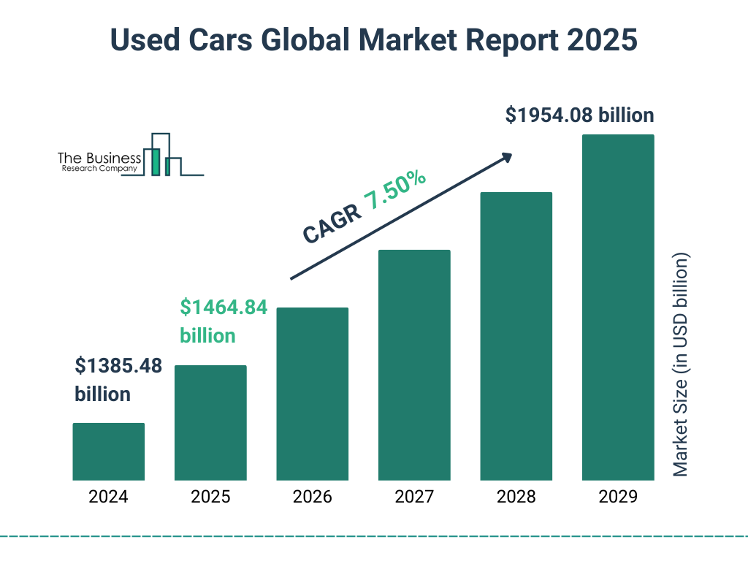
Figure 1 Used Cars Demographics Global Market Report (“Used Cars Market Report 2025 - Used Cars Industry and Share,” n.d.)
The use of machine learning, especially that of supervised regression models, has been promising in predictive modelling continuous variables e.g. price, using structured data. These models can provide more consistent and accurate responses as they will be able to recognize the patterns in historical data helping them to perform the predictions more accurately, lowering the dependency on manual judgments. Because of that, many scholars and professionals have tackled the use of machine learning to automate and optimize the valuation of used cars (Lin et al., 2025).
However, these changes today as witnessed in this literature review, vehicles final prices are being predicted through new methods unlike the traditional approaches. It explains how well different machine learning models like Linear Regression, Decision Trees, Random Forests, Gradient Boosting and Support Vector Regression work regarding vehicle pricing. The relevance of feature selection, data preprocessing methods, the performance assessment criteria, and the incorporation of predictive models into web-based systems will also be taken into consideration in the review. This part provides a basis of the present project and gives a name to gaps in the research by critically evaluating the current studies on the subject (Zhang, 2025).

2.2 Price prediction of a vehicle: Conventional vs Deep Learning-based
Pricing of used cars has always been a subjective exercise which largely depended on the field experience of car dealers, motor mechanics, and other practitioners. The usual practice that is used is by manual inspection as well as using experience as grounds of opinion, observation of trends in the market, and using printed rules of guidance on valuation. Such methods do come in handy in some cases, but they are internally restricted by human bias, lack of consistency, and scalability. What two people are likely to have major variations in its price estimation is the same car, based on the place the estimator is found, the knowledge or the availability of similar information. These constraints are the more tangled as the used car market is getting more and more in volume and complexity, especially to both the consumers who demand fair and transparent prices (Byeon et al., 2024).
Table 1 Comparison of Traditional vs. Data-Driven Pricing Models
Aspect | Traditional Pricing Model | Data-Driven Pricing Model
Basis for Valuation | Expert opinion, visual inspection, dealer experience | Historical data, statistical patterns, and machine learning algorithms
Transparency | Low based on subjective evaluation | High objective, data-backed decisions
Accuracy | Varies greatly; inconsistent across sellers and locations | More accurate due to model training on large datasets
Scalability | Difficult to scale requires human input | Easily scalable can evaluate thousands of vehicles in seconds
Bias and Subjectivity | High affected by personal judgment and negotiation | Low minimizes human bias with consistent evaluation criteria
Adaptability to Market Trends | Slow dependent on individual dealer awareness | Fast can be retrained with new market data regularly
Required Expertise | Needs professional or dealer experience | Requires technical setup but minimal user expertise for end users
Time Efficiency | Time-consuming manual process | Instantaneous predictions
User Trust | May lead to skepticism due to lack of justification | Build trust with transparent and repeatable predictions
Cost | High may involve inspection or valuation service fees | Low once deployed, model runs at minimal cost

Another problem faced when applying the traditional valuation systems to the second-hand market is that they are not well suited to the dynamic second-hand market, as the prices may change according to the external factors, very often in the second-hand market as compared to the new car market. Manual pricing does not respond favorably to this type of variability, and it tends to lag reality in the market. Moreover, individual buyers and sellers who may not have professional knowledge or access to vast amounts of information about transactions cannot be expected to be in a good position to decide what the right value of a particular vehicle is. Such an imbalance adds to inefficiency and perceived unfairness in the market (Sharma and Mitra, 2024).

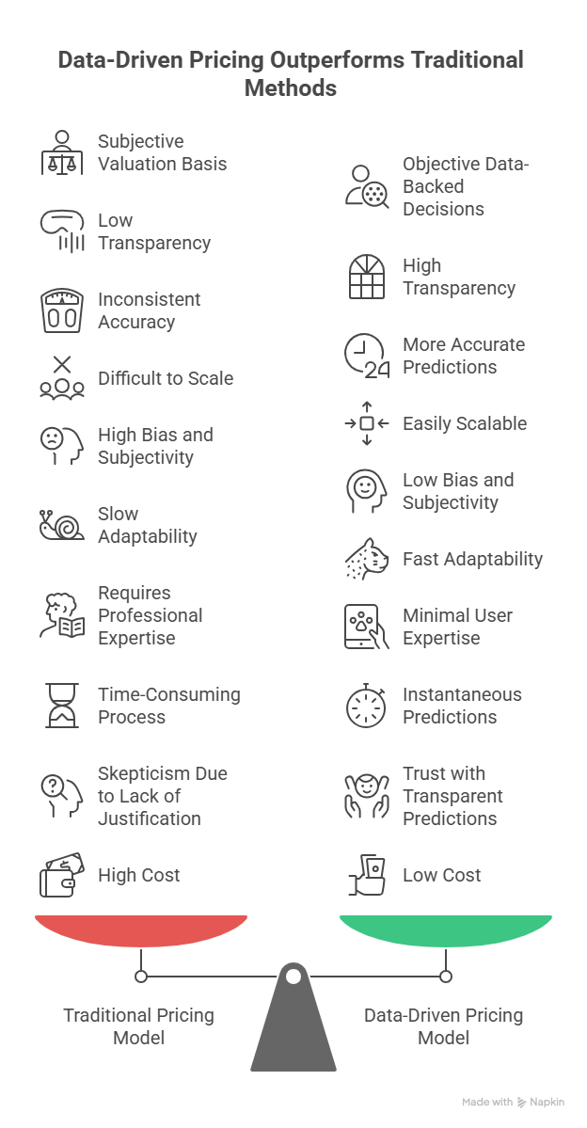
Figure 2 Data-Driven Pricing Outperforms Traditional Methods
Conversely, data driven methods of prediction of price of vehicles are a more objective, consistent and scalable alternative. They are based on the large great quantity of past sales data, characteristics of the vehicle and buyer behavior analysis to draw patterns and similarities, which impact price. With the use of statistical and machine learning methods, vehicle prices, as measurable characteristics like brand, model, mileage, year of manufacture, engine capacity, fuel type, and transmission, can be estimated through predictive models (Pasupuleti et al., 2024). This allows more relevant and individual estimations that correspond to real market forces. When it comes to machine learning, it has turned out to be a revolutionary tool in this field. In contrast to classical statistical models of data analysis, ML can process data that is very high dimensional and can therefore discover nonlinear relationships amid the variables. Some of the algorithms used and have been useful in modeling the pricing structures with high precision are Decision Trees, Random Forests, and Gradient Boosting Machines (GBM). The models do not respond to changes indefinitely as these models learn new responses with each change in the market (Robin et al., 2025). These models respond to market changes more effectively than the human-based methods that were constant and could not adapt to the market changes.

2.3 Vehicle Price Regression Models
Regression analysis has found extensive application in the problem of prices. Supervised regression models are especially effective in the situation with used cars because of the presence of labeled datasets.

2.3.1 Linear Regression
Linear Regression can be considered as one of the simplest, as well as interpretable, algorithms utilized to predict continuous values. Several studies have applied this model in the conduct of their vehicle price forecast studies, and they have been successful in the study when the correlation between dependent and independent variables is just about linear. Its performance, however, is usually hindered when it comes to handling complex and nonlinear relationships or interactions between the variables (Bergmann and Feuerriegel, 2025a).

2.3.2 Regression by Decision Tree
Decision Trees are non-parametric models that divide the data into branches according to the values of features. They are also convenient, self-intuitive, and can manage non-linear relationships. Research indicates that Decision Trees can approximate complicated used car pricing situations, although it is subject to overfitting, particularly when it is not appropriately pruned.

2.3.3 Support Vector Regression (SVR)
Support Vector Regression is a reliable method which tries to generate a functional, within a margin threshold which approaches the real data. At the same time, SVR is especially effective in the case of outliers and high-dimensional feature space. It has been implemented on some vehicle pricing tasks with some success, though the parameter settings such as the type of kernel used and the regularization are tasks requiring some expertise (Rigby et al., 2024).
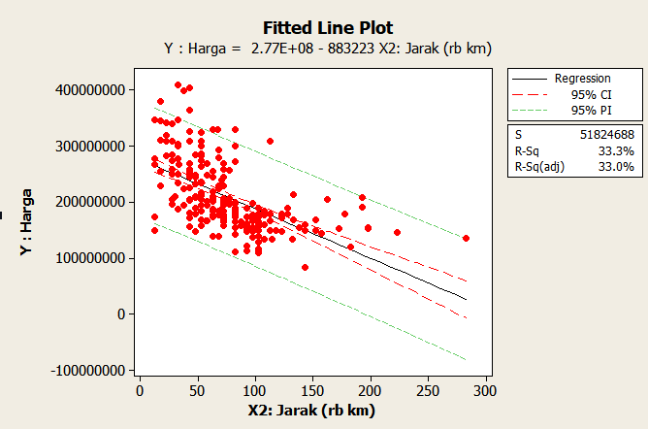
Figure 3 Fitted line plot of car prices (“ Fitted line plot of car prices against car mileage.,” 2025.)

2.3.4 Random Forest Regression
Random Forest is a modeling technique that is an ensemble method that forms multiple decision trees and combines predictions to make one. It lowers the possibility of overfitting and enhances the overall accuracy of the model. It has been indicated in literature that Random Forest has been very successful in predicting the used car price because it can deal with a large number of features and variable interactions (Kridiawan et al., 2025).

2.3.5 Gradient Boosting Regression
Gradient Boosting is the other ensemble learning method, and it develops models consecutively in a way that one model enhances the other. Such algorithms as XGBoost and LightGBM demonstrated good performance and resiliency in the task of predicting car prices. They are especially preferred in their competitions in contested machine learning settings and scale of data settings. Additionally, having information-driven systems will also lead to automated platforms that provide prices in real time in recommendations, boosting both the customer and seller in the decision-making process and simplifying the consumer experience. The distribution of those models through web-based applications goes even further to distribute access to advanced analytics to a wider group of people, independent of their technical background (Romano et al., 2025). In short, although the long-standing methods have worked in the used vehicle sector for decades, they are gaining more advanced substitutes or complements with data-driven techniques where better precision, transparency, and scalability are promised. The transition to predictive analytics is a milestone step to the change in the way vehicles are valued, which will enable more equitable, timely, and stable pricing in the car sector.

2.4 Feature Engineering and Dataset Characteristics
The process of feature engineering is one of the most significant throughout the building of a machine learning model since it has a direct effect on how well the model adapts to learn patterns out of data. As applied in the fields of vehicle price prediction, the process of feature engineering is beneficial, since it seeks to find the variables that will reflect the qualities influencing the market value of a vehicle, and the selection of these variables and their transformation to an appropriate form. The composition of input features is significantly important because it determines the accuracy and performance of any regression model (Zhang et al., 2025).

2.4.1 Profile of the Dataset
This project will use the data set, which contains a historical list of used cars including both quantitative and categorical variables. These records are normally scraped by internet marketplaces and car dealership sites to give a rich mix of various vehicle types, conditions, and price ranges. Every entry will be related to a particular vehicle, and it will have various features that will determine its price. The dataset contains key features as categorical variables that reflect the manufacturer and type of a certain vehicle. There are brands that have a better retention of resale value based on reliability and fame (Kuhnl et al., 2024). Allow the age of the vehicle to be presented, which directly influences depreciation and market value. Evidence of the amount of usage of the vehicle. The more mileage, the lower the value. There are typical categories, namely petrol, diesel, hybrid, and electric. There is a buyer preference in fuel costs and fuel efficiency. Machines or manual transmission can influence desirability and, thus, the price. The bigger the engine, the higher the performance be the performance which is accompanied by high fuel consumption. The brand and the model of the vehicle could be counted into the car structure (e.g., sedan, SUV, hatchback) and affect the price according to the demand on the market. All these features provide an essence of an in-depth look at the specification, condition, and marketability of every vehicle (Marnholkar, 2025).

2.4.2 Data Cleaning and Preprocessing
To make the dataset ready to use with the machine learning algorithm, it must first pass several preprocessing stages before the development of the model:
Missing Value Treatment The value of Missing or NULL values is either replaced by a suitable statistical measure (mean, median or mode) or deleted in case it constitutes a minimal percentage of the whole collection. Outlier Detection to avoid skewed model training, outliers in numerical columns, e.g., in terms of mileage or price, are detected and thwarted with interquartile range (IQR) techniques. Data Type Conversion: some features will be converted to the proper format- e.g. year column will be converted into the age column (Edwards et al., 2024) .

2.4.3 Coding of Categorical Variables
Categorical data like brand, model, fuel type, and transmission are encoded and converted into numerical representation because most machine learning models expect numerical input:
- Label Encoding places each category to a specific integer. It is easy and can present unwanted ordinal relationships.
- One Hot Encoding makes columns that are turned into 0-1 and have no implicit ordering to them. This is particularly effective in terms of such things as fuel type or transmission.
- Label encoding or one-hot encoding specializes in a particular algorithm and vice versa. Label encoding is easily applicable to tree-based models such as Random Forest, whereas one-hot encoding is usually more informative to linear models (Alazemi et al., 2025).

2.4.4 Scaling the features
Scaling methods are used to rule out unfair weighting of numerical features:
- Standardization (Z-score): Features are rescaled such that they have zero meaning and unit variance.
- Normalization Min-Max: values between 0 and 1.
This is especially relevant to algorithms that are sensitive to feature magnitude e.g., Support Vector Regression and Gradient Boosting.

2.4.5 Selection of features:
The features do not have equal prediction power for the model. The irrelevant or redundant features might inject noise and decrease performance. They use feature selection methods- correlation analysis and model-based importance ranking (e.g., feature importance scores using Random Forest) to drop the least effective features. The latter group of features is chosen in terms of domain relevance, statistical significance, and providing an accurate model. This is cleaned data, which then becomes the input of the model training and evaluation (Hossain et al., 2025).

Section 2.5: Evaluation Metrics
When it comes to regression tasks in the specific case of the price prediction model, the evaluation metrics are essential in terms of evaluating the accuracy and generalization of the model used. Mean Absolute Error (MAE), Mean Squared Error (MSE), Root Mean Squared Error (RMSE), Coefficient of Determination and the Coefficient of determination, R squared (R 2) are the common measures applied in literature. MAE computes an average of absolute differences between the predicted and actual values, providing informal knowledge of how much the model is likely to err in the very unit of the output variable, here being the price of the vehicle. MSE instead squares these error values before averaging, proportionally penalizing the large errors more than MAD, and, therefore, is more sensitive to outliers. More easily interpretable as an original output variable, unlike MSE, RMSE is the square root of MSE, and, thus, retains the characteristic of larger errors being penalized more heavily than smaller ones. Finally, R2 is the measure of how much of the variance in the dependent variable can be predicted by the independent variables, and values near 1 represent a higher predictive capability. This project, with the mixture of these measurements, would lead to a more secure and thorough analysis of every single regression model, and, therefore, the most powerful and correct algorithm would be chosen to predict the price of used cars (Ding et al., 2024).

2.6 Web-Based Applications for Predictive Modeling
Over the past few years, web-based apps have witnessed a lot of momentum about the use of machine learning models. This is following the growing demand to bring together complicated predictive systems to the mainstream end-users on a more user-friendly platform, as they are not necessarily experts at being technical. Web applications are a pathway between wonderful backend algorithms and real-world, applied operations, where people can engage with machine learning models easily and intuitively (Yohanes and Lasut, 2025).
Table 2 Popular Frameworks for ML Web Deployment
Framework | Language | Strengths | Typical Use Case
Flask | Python | Lightweight, flexible, easy to use | Custom web apps, APIs
Django | Python | Full-featured, scalable | Complex web applications
Streamlit | Python | Fast prototyping, simple UI | Interactive dashboards and demos
Node.js | JavaScript | High performance, event-driven | Real-time applications, APIs

Within the scope of vehicle pricing prediction, the use of web-based systems allows a buyer and a seller of the vehicle to enter the specific vehicle characteristics including the make, model, mileage, type of fuel, and the year of its manufacture and obtain the current estimation of the vehicle value in the market in an instant. This enables informed choices and fair pricing. Contrary to the fixed pricing guides, they can be updated in real-time with additional information or trained models to guarantee that the forecasts are up-to-date and well-informed. Many frameworks are generally used to deploy machine learning models on the web. Common Python-based web frameworks include Flask and Django, which enable developers to plug trained models on the server-side of application execution. These frameworks offer a malleable backend functionality, authentication of users, and database integration; therefore, they have been applicable in the scalable application. Streamlit on the other hand, has become the preferred method of rapid prototyping and deploying data scientists (Thomas and Serrenho, 2024).
It also supports rapid translation of Python scripts to interactive web interfaces with very little code and is thus perfect for projects with an emphasis of simplicity and fast development. The introduction of regression models in web applications has proved useful in previously conducted studies and projects. As an example, there is an application designed for property valuation, loan default prediction, and health diagnostics uses, and they have a similar configuration of the user input and real-time output. These are only examples of how versatile web based predictive systems are and their effectiveness across industries. Irrespective of such benefits, there are some challenges. The privacy of data, scale, and responsiveness of models within the Web-based applications of ML should be ensured. In addition, the integration process demands attention to compatibility with model serialization formats, performance improvement, and interface usability. Periodic retraining and updates would also be required in ensuring that the model remains good to be used in production settings particularly when there are changes in the pattern of user input. To conclude, web-based applications are a highly effective possibility to provide predictive modeling tools to a larger audience. With this project, by including in it the best model to predict the price of a vehicle into a friendly user Internet-based platform, our system will have more practical value to it. It allows giving the user real-time, data-based insights and helps provide more transparent and equitable transactions in the used car market (Yohanes and Lasut, 2025).

2.7 Category of Research Gaps
Regardless of the recent increase in the use of machines to predict the prices of vehicles, there are still a couple of gaps in the available research:

2.7.1 Limited Comparative Analysis of Models:
Most of the previous literature is limited to either the application of one regression algorithm or the comparison of a few of the models. Extensive comparison of larger sets of algorithms (both ensemble and traditional) is few. This restricts the power to make conclusive statements as to which model works better in the real market, where real conditions apply, and where diverse data sets work.

2.7.2 Mismatched Measurement System in Different Studies:
MAE, MSE and R2 have become standard metrics, but because the evaluation methods vary between studies, it is not easy to measure performance consistently. A common method of determining the accuracy of a model would help in improving comparable and trustworthy results.

2.7.3 Little Attention to the Effect of Feature Engineering:
Incorporation of simpler characteristics of vehicles like age, mileage and brand being used in most of the investigations whereas many of the complex or derived characteristics like regional pricing patterns, depreciation characteristics historically or seasonal effects are not investigated. Such uncharted variables have the potential of improving the accuracy of models in a big way (Yarra et al., 2025).

2.7.4 Ensemble Techniques underutilization:
Random Forest and Gradient Boosting are ensemble methods, which are very useful in the tasks of predictive modeling. Nevertheless, they are unharnessed in one of their areas of use in predicting the prices of used cars. Not many works exist that systematically compare those techniques with simpler ones to show their effectiveness or the value of their extra cost of calculations.

2.7.5 Lapses in Real-Life Deployment and Availability:
Even in cases where valid models are developed, they tend to end up being only within the academic or technical settings without being applied practically. The gaps being that there are no user-friendly applications which combine these models into user-friendly real-time systems that can be utilized by everyday members like car buyers, car sellers or car dealerships (Gössling et al., 2024).

2.7.6 Cross-Market Generalization:
Most of the datasets and studies are regional, and mostly capture one region, country, or market. Consequently, the results as well as models could not be generalized or applied in various geographical or economic settings. This limitation might be overcome by employing broader datasets or flexible models.

2.7.7 Explainability and Trust in Forecasts:
One can also observe the lack of research on model interpretability. To be trusted by end-users, and particularly in the case of high-value purchases, such as a vehicle, models should present explainable details of the prediction process The realization of these research gaps is the basis of this project, which is going to implement and compare the existing machine learning algorithms and test their performance based on a set of common measures and deployment of the most efficient model as a user-friendly web application to empower transparent and evidence-based pricing in the used car market (Yarra et al., 2025).

2.8 Summary
The chapter has discussed some of the critical literature in the industry regarding used vehicle price prediction using machine learning. Incumbents' pricing mechanisms in the second-hand car market are subjective and inconsistent, which creates the need of objective and data-driven mechanisms. There have been different regression models that are supervised and have discussed different models, including Linear Regression, Decision Tree, Support Vector Regression, Random Forest, and Gradient Boosting, and in such models, it was found that an ensemble method tends to be more accurate and robust.
Throughout the literature, great attention has been paid to the necessity of quality feature engineering, proper preprocessing of the dataset, and evaluating the model using such metrics as the MAE, MSE, and R 2. Also, predictive model implementation into user friendly web based applications is picking up pace because it adds on the ease of access and application. Despite this development, there are still overlaps in comparative studies of various models in a comprehensive structure, as well as the application of such models to actual use in the public world. The given project attempts to fill those disparities by applying several machine learning algorithms, compare them and programing the most successful one into an interactive web app to ensure that the used car marketplace is as clear and sound in terms of decision making as possible.

Chapter 03: Methodology

3.1 Introduction to Methodology
The chapter describes the steps followed to develop, train, test and deploy a machine learning model to predict prices of used cars. It is a well-organized pipeline data acquisition, some data preprocessing, the exploration of data (EDA), feature engineering, model selection, evaluation, and ultimate deployment, in the form of a web application with Streamlit. Traditional machine learning algorithms, as well as complicated deep learning approaches, are also included in a comparative analysis.

3.2 Research design
This research is quantitative and empirical, where the supervised regression algorithms are used to predict automotive prices, depending upon the well-organized characteristics. The work is experimental and involves training a model, validation of that model, and performance comparison.

3.3 Description of the dataset
The dataset implemented in this work is a cleaned and merged set of UK’s used car ads in the Kaggle listings, which includes data of seven of the most well-known automotive brands: Audi, BMW, Skoda, Ford, Volkswagen, Toyota, and Hyundai.
- Total Rows: 72,435
- Total Columns: 10
Table 3 Key Features of the Dataset
Feature | Description
price | Target variable (selling price in GBP)
brand | Car brand (e.g., Audi, Ford)
model_year | Year of manufacturing
transmission | Type of transmission (manual/automatic)
mileage | Distance the car has been driven
fuel_type | Fuel used (e.g., Petrol, Diesel)
road_tax | Yearly road tax payable
mpg | Miles per gallon (fuel efficiency)
engine_size | Size of the car’s engine in litres

3.4 Project Workflow
The overall workflow for this project is composed of the following phases:
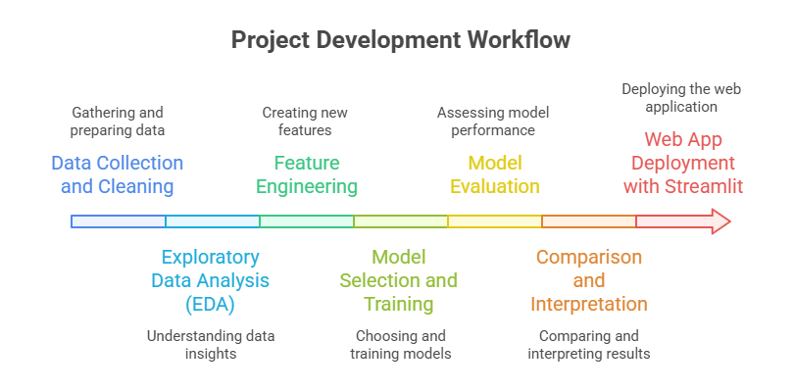
Figure 4 Project Methodology Flowchart

3.5 Preprocessing Data
The following are some of the steps that are taken in readiness to model the data set:
When the records on Missing Value contain missing or inconsistent values, they are either dropped or imputed. Encoding Categorical Features Categorical features are encoded by one hot encoding, which is to say, for example, that nominal features such as fuel type and traffic are encoded differently. New features, best engineers' features. Numeric attributes such as mileage and engine size are transformed with the StandardScaler or MinMaxScaler (Thomas and Serrenho, 2024).

3.6 Exploratory Data Analysis (EDA)
Python libraries including Pandas, Matplotlib, and Seaborn are used to administer EDA. This includes:
- The univariate and bivariate analysis
- Correlation matrix to determine major relationships
- Prices of cars in terms of brand, mileage, type of fuel etc.
- Box plot-based outlier detection

3.7 Models of Machine Learning
The techniques are used in comparative sense through both regular and sophisticated models.

3.7.1 Modeling with Traditional Machine Learning
- Linear Regression baseline mode of predicting.
- Decision Tree Regressor that reflects the non-linear correlation.
- Ensemble model of Random Forest Regressor that has better accuracy.
- A Boosted ensemble model is Gradient Boosting Regressor (e.g. XGBoost).
- SVR works easily on high-dimensional regression.

3.7.2 Deep-Learning Models
- Neural network model that uses Keras or PyTorch to build One or more hidden layers of the Multilayer Perceptron (MLP) network.
- Hyperparameter Tuning The following was done using GridSearchCV (ML models) and Keras Tuner (deep learning models).

3.8 Evaluation Metrics
Model performance is measured using the following regression metrics:
Table 4 Model performance Metrics
Metric | Description
MAE | Mean Absolute Error average absolute difference
RMSE | Root Mean Squared Error penalizes large errors
R² Score | Coefficient of Determination, goodness of fit

3.9 Model Comparison and Selection
Each trained model is compared relative to its MAE, RMSE, and R 2 values. To simplify the analyses and clarify the differences between the model performances, visual plots (e.g., bar charts or heatmaps) are applied. The most effective model will be deployed.

3.10 Streamlit Deployment
So that it can be user-friendly and accessible, the model is further implemented as a Streamlit web app. The main peculiarities are to enable users to enter the features of cars (brand, mileage, year, etc.). There are displays of importance and confidence intervals. It is shareable by a public URL or local hosting.

3.11 Tools and Technologies
The tools used in the project are.
Table 5 Tools and Technologies
Tool/Library | Purpose
Python | Programming language
Pandas, NumPy | Data manipulation
Scikit-learn | Machine learning models
XGBoost | Advanced boosting model
TensorFlow / Keras | Deep learning implementation
Seaborn, Matplotlib | Data visualization
Streamlit | Web application deployment

The present project has a well-organized and data-driven approach of forecasting the prices of used cars with both normal machine learning and deep learning models. It will commence by obtaining a clean dataset of more than 72,000 records of the UK used car market including the brands like Audi, BMW, Ford, and Toyota. The essential characteristics are mileage, the type of fuel, transmission, the size of engines and the road tax used in predictive modeling.
The data is subject to preprocessing such as missing value imputation, categorical variable encoding and feature engineering (e.g. computing age of the vehicle). Exploratory Data Analysis (EDA) is done to discover trends and relationships in the data. Several supervised regressions models such as Linear Regression, Decision Tree, Random Forest, XGBoost, SVR, and a Deep Learning-based Neural Network are implemented and tested on the basis of performance scores, like Mean Absolute Error (MAE), Root Mean Squared Error (RMSE), and R-squared (R2 ).
The importance of the features is studied to determine the features that are the most important in forming vehicle prices. The most effective model is chosen on the premises of evaluation metrics and explainability. And, finally, the chosen model is implemented in the form of an interactive web application via Streamlit so that a user can provide information concerning a vehicle and obtain predictions regarding its price immediately. Such an end-to-end pipeline will require the development of a feasible, scalable, and intuitive pricing application that can facilitate meaningful price discoveries and help in transparent decision-making within the used car market.

Chapter 04: Expected Results and Discussion
4.1 Introduction to Results
A discussion of the anticipated results to be achieved by the current project (developing a price prediction model that is based on machine learning and used cars) has been included in this chapter. The results of the evaluation are not provided since the implementation is in the process of being implemented. Nevertheless, the performance of the desired model, the significance of the attributes, which it considers, and the importance of the project as a whole will be outlined in this chapter according to the initial data exploration, strategy of selection of the model, and the research findings stated in the literature. There are also first ideas regarding data preprocessing and exploratory data analysis (EDA) to show the first results.

4.2 Initial Progress
The key activities that have been accomplished at this point in the project include the following:
- The data set with information about more than 72 thousand vehicles of seven brands as second-hand was chosen and successfully imported to the development environment (Jupyter Notebook).
- Data cleaning methods have been used to deal with missing values, inconsistent values.
- The process of the exploration data analysis was initiated, and it includes the illustration of major characteristics, including the price distribution, mileage, type of transmission, and type of fuel.
- Feature engineering operations like vehicle age using model year calculation are underway to help model performance further in the future.

4.2.1 Dataset Loading and Initial Exploration
A cars_dataset.csv dataset was uploaded and run in the environment of Jupyter Notebook. It has 72,435 rows and 10 columns that contain information about the cars used of the seven largest automakers of the UK. Its main characteristics are:
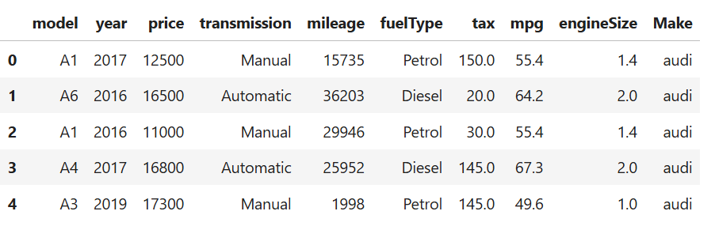
Figure 5 Dataset Loading and Display in Python
model, year, price, transmission, mileage, fuel Type, tax, mpg, engine Size, and Make (which I have renamed to brand).
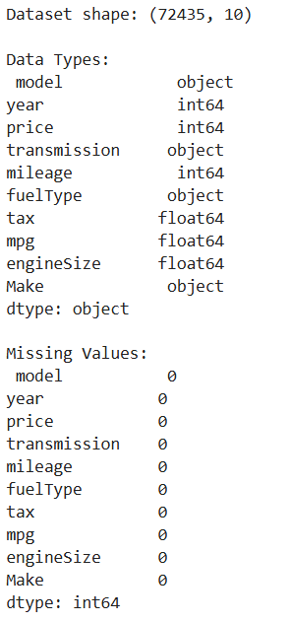
Figure 6 Dataset Shape and Missing Values
The missing values were also checked via python in the dataset. A summary of statistics was used to confirm that there is variability within numerical variables like the price, mileage, and engine size, and to provide the possibility of meaningful regression analysis.
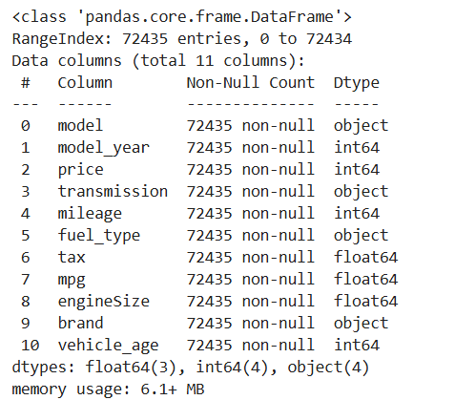
Figure 7 Checked Datatypes

4.2.2 Exploratory Data Analysis (EDA)
Several visualizations were generated to understand the data and feed into modeling:
Price Distribution implies that during modeling, we should also consider how outliers will be dealt with.
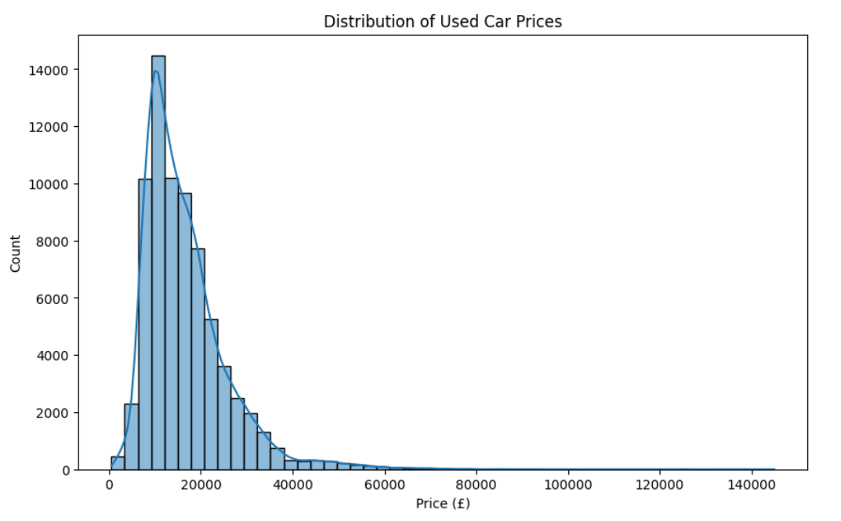
Figure 8 Distribution of Used Car Prices
Average Price by Brand Here the BMW and Audi brands were featured with higher average resale values than those of Hyundai and Skoda, which makes the brand a possible high-importance factor.
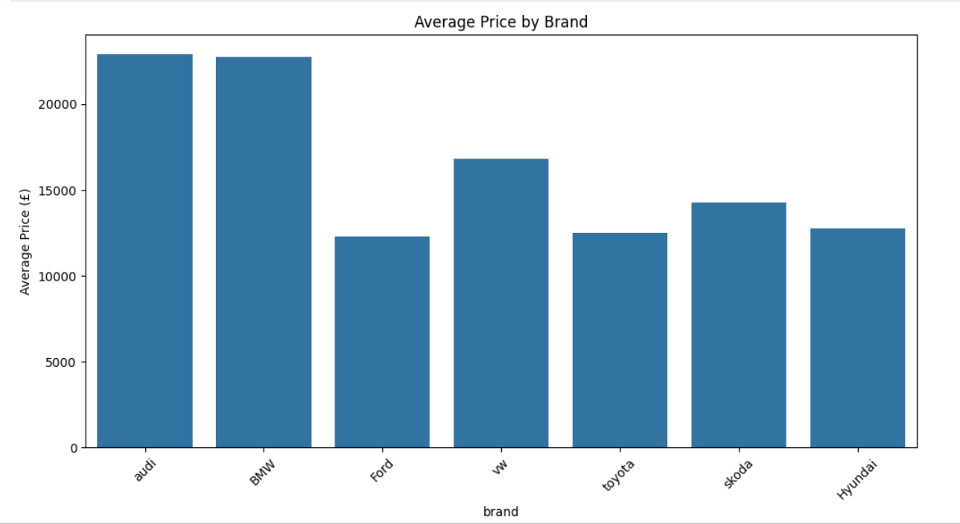
Figure 9 Average Price by Brand
Type of Transmission Count shows that here mostly manual transmission vehicles, though there were slightly more average numbers of an automatic vehicleClassification Cross-Tabulation Results in Subsequent Cross-Tabulations The average price was also higher in automated vehicles, which was demonstrated by the outcome of cross-tabulation.
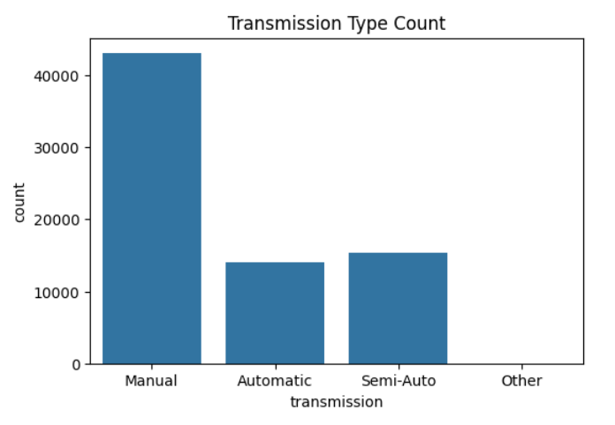
Figure 10 Transmission Type Count
Mileage vs Price supports the hypothesis that increased mileage leads to low resale value and will be a significant variable under regression model.
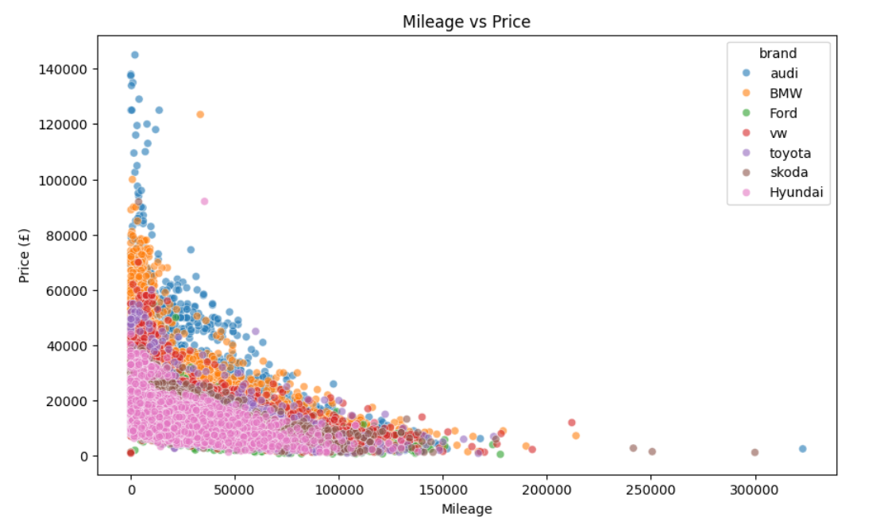
Figure 11 Mileage vs Price
These findings give credence to the hypothesis that the features like brand, mileage, type of transmission and age of the vehicle are very important in determining the price of a vehicle.

4.3 Early Observations
Data visualization. Preliminary data visualization has shown several patterns and trends:
- The prices of cars are skewed to the right where most used cars are priced at less than 20000 pounds. The difference in price levels is also quite high in some luxury models which means that there might be outliers, which require treatment.
- BMW brands and Audi, on average, appear to be pricier compared to the prices of Skoda, and Hyundai brands.
- With mileage and price, the negative correlation establishes that high mileage diminished the resale value of a car.
- The price of an automatic car would seem to be a little above average compared to that of manual cars.
- Also, the same is the case with diesel and hybrid cars where they usually do not follow the same trend when it comes to their prices as compared to petrol powered cars.
These results indicate that brand, mileage, transmission, type of fuel and age are probable to feature highly in the final model.

4.4 Expected Results from Model Training
According to the chosen regression algorithms and other related works in academic sources, the below results will be expected: ensemble methods like Random Forest and XGBoost will perform better than the usual linear models in terms to accuracy and stability, in particular, to discover non-linear tendencies and interactions with characters. Expected results on the performance of the best models can be the Mean absolute error (MAE) is expected to be around 1,000-2, Root means squared error (RMSE) is a little more than MAE, as it makes bigger errors more costly to bear. The R2 score is expected to be greater than 0.85 in case of best-performing models which implies High Fit between features and the target variable. The factors that will have contentious positions in their comprehension of influence on pricing will be mileage, vehicle age, engine size, and brand, with some inclusion of fuel type and transmission.

4.5 Expected Deployment Result
As soon as the most suitable and effective model is found, it is going to be incorporated into a client-friendly web-based application created with the help of Streamlit. The App should:
- Give users the ability to enter important vehicle characteristics through a form interface
- Show a market estimate at a glance
- Optional visual interpretation e.g. features contributions or confidence intervals
The aim is to open this device to a wide range of users, that is, to individual buyers, individual sellers, and dealerships, which would enhance the level of transparency and decision making made in the used car market.

4.6 Potential Challenges
Although the process of the project implementation proceeds according to the plan, there are some challenges which could occur in case of further stages:
- When working with ensemble and deep learning models, in particular, one should be careful when it comes to overfitting the results, making sure that adequate cross-validation and regularization methods are used.
- The dataset may be skewed towards certain brands or types of fuel, a situation that may cause inferences to be biased. This will have to be done using sampling or feature balancing technologies.
- Optimization of the model or lightweight substitutes to ensure the deployed model can operate fast and accurately on a web-based environment may be necessary.

4.7 Summary
To conclude, the preliminary work on the project has provided the firm foundation to the creation of a valuable machine learning model to predict the prices used by cars. The importance of early EDA and data cleaning has provided insight into the relation between the features and price trend. The anticipated findings note that ensemble models most probably will be the most suitable to result in predictions, whereas deployment through Streamlit will make predictions have practical, real-life applications. The upcoming steps will be model training, tuning, testing, and final deployment that will be reported in the final project report.

Chapter 05: Conclusion
This report has shown the preliminary work of development of the machine learning based model that could predict the price of used vehicles in the UK market. Motivation to work on the project is the increased complexity and subjectivity of the second-hand automotive market in general and the demand of consumers and sellers to get more candor, precision, and analytical pricing tools in the market.
By the next stage of the IPR, the dataset was acquired due to the Kaggle repository and preprocessed so that it could be qualitative and practical. The most important things which have been done are:
- Stratified loading and structural checkup
- Deletion of missing or erratic records and cleaning of records
- Features produced by feature engineering (e.g. vehicle_age)
- Exploration and data analysis to realize relationships among features and price
- Coding of categorical variables before the construction of machine learning models
Preliminary results of EDA confirm the hypothesis that the resale value is greatly dependent on such variables as a mileage, car age, a car brand, and engine size. The patterns presented during visualizations match the dynamics of automotive pricing in the real-world, which was a very good basis to train models.
Even though the training of final models has not been completed, a specific roadmap of methodological approach was developed. The next step will fix a combination of classic regression algorithms and complex models (e.g., Random Forest, XGBoost, and neural networks) to assess the predictive performance. Each of these models will be compared in a strict manner by using popular metrics like MAE, RMSE and R 2.
The following project stage will be concerned with the implementation, optimization, and deployment of machine learning models. Activities that will be undertaken entail:
- The cleaned dataset will be used to train multiple models of supervised learning. Grid search and cross-validation will be used to perform hyperparameter tuning and optimize model performance.
- Comparison of each model will be done in detail by similar evaluation measures. The final model will be chosen based on both its accurateness and interpretability.
- One aspect considered is the model-based metrics of importance and SHAP values of how features affect price predictions to improve transparency and trust in the user.
- The most accurate model will be implemented as an easily operated web application with the help of Streamlit. With the use of this site, the user will be able to enter the features of a vehicle and get an approximate value of that same vehicle in the market.
- All the steps of the process, including the data pre-processing and deployment stages will be fully documented. There is a possibility to incorporate a usability test of the application when there is time.
- All model outcomes, limitations discussion and future enhancement recommendations will be made in the final project report.
This project has an interdisciplinary role to play in both data science and automotive industry since it engages in the application of a realistic, user-driven solution to a real-world problem. Although progress to date indicates a successful process, this interim report represents the next steps in the integration of the three phases, modeling, evaluation and deployment to produce a functional and effective pricing tool. This result has the objective not only to help people and companies with more efficient decision-making but also to illustrate the capabilities of machine learning once safely used in the field of daily economic issues.

References
Abu Ghareebaih, Y., 2025. Car Price Prediction Using Machine Learning: Analyzing the DVM-CAR Dataset.
Alazemi, F., Alazmi, A., Alrumaidhi, M., Molden, N., 2025. Predicting fuel consumption and emissions using GPS-based machine learning models for gasoline and diesel vehicles. Sustainability 17, 2395.
AMBUR, A.T.A., Ahmed, B.T., 2025. Car Price Prediction Using Machine Learning: A Data-Driven Approach. Journal of Mathematics and Artificial Intelligence 1, 40–46.
Bergmann, S., Feuerriegel, S., 2025a. Machine learning for predicting used car resale prices using granular vehicle equipment information. Expert Systems with Applications 263, 125640.
Bergmann, S., Feuerriegel, S., 2025b. Machine learning for predicting used car resale prices using granular vehicle equipment information. Expert Systems with Applications 263, 125640.
Byeon, H., Prashant, G.C., Hannan, S.A., Alghayadh, F.Y., Soomar, A.M., Soni, M., Bhatt, M.W., 2024. Deep neural network model for enhancing disease prediction using auto encoder based broad learning. SLAS technology 29, 100145.
Das, K., Kumar, R., Krishna, A., 2024. Analyzing electric vehicle battery health performance using supervised machine learning. Renewable and Sustainable Energy Reviews 189, 113967.
Ding, C., Wang, Y., Cao, X.J., Chen, Y., Jiang, Y., Yu, B., 2024. Revisiting residential self-selection and travel behavior connection using a double machine learning. Transportation research part D: transport and environment 128, 104089.
Edwards, P.J., Moore, S., Higgins, C., 2024. Pedestrian safety on the road to net zero: cross-sectional study of collisions with electric and hybrid-electric cars in Great Britain. J Epidemiol Community Health 78, 487–492.
Figure 3. Fitted line plot of car prices against car mileage. [WWW Document], n.d. . ResearchGate. URL https://www.researchgate.net/figure/Fitted-line-plot-of-car-prices-against-car-mileage_fig2_340177972 (accessed 7.14.25).
Gössling, S., Schweiggart, N., Nieuwenhuijsen, M., McEachan, R.R., Khreis, H., 2024. Urban transport system changes in the UK: In danger of populism? Cities 153, 105273.
Hossain, M., Rabbi, M.M.K., Akter, N., Rimi, N.N., Hamid, M., Amjad, H., Chowdhury, B.R., Ridoy, M.H., Alam, S., Sadik, M.S., 2025. Predicting the Adoption of Clean Energy Vehicles: A Machine Learning-Based Market Analysis. Journal of Ecohumanism 4, 404–426.
Kridiawan, Y., Warnars, H.L.H.S., Prabowo, H., 2025. Machine Learning-Based Data Strategies in Automotive After-Sales Services: Systematic Literature review. Machine Learning 32.
Kuhnl, A., Roddie, C., Kirkwood, A.A., Chaganti, S., Norman, J., Lugthart, S., Osborne, W., Gibb, A., Gonzalez Arias, C., Latif, A., Uttenthal, B., Seymour, F., Jones, C., Springell, D., Brady, J.L., Illidge, T., Stevens, A., Alexander, E., Hawley, L., O’Rourke, N., Bedi, C., Prestwich, R., Frew, J., Burns, D., O’Reilly, M., Sanderson, R., Sivabalasingham, S., Mikhaeel, N.G., 2024. Outcome and feasibility of radiotherapy bridging in large B‐cell lymphoma patients receiving CD19 CAR T in the UK. Br J Haematol 205, 483–494. https://doi.org/10.1111/bjh.19453
Lin, S., Song, D., Cao, B., Gu, X., Li, J., 2025. Credit risk assessment of automobile loans using machine learning-based SHapley Additive exPlanations approach. Engineering Applications of Artificial Intelligence 147, 110236.
Manuguerra, L., Cappelletti, F., Germani, M., 2024. A machine learning based method for parametric environmental impact model for electric vehicles. Journal of Cleaner Production 454, 142308.
Marnholkar, T., 2025. PRE-OWNED CAR PRICE PREDICTION: A MACHINE LEARNING APPROACH. Available at SSRN 5189395.
Pasupuleti, V., Thuraka, B., Kodete, C.S., Malisetty, S., 2024. Enhancing supply chain agility and sustainability through machine learning: Optimization techniques for logistics and inventory management. Logistics 8, 73.
Rafsan, R., Rusho, M.A., Ahsan, J., Afrad, R.H., Dhrubo, A.F.H., Jahan, M.K., Qayum, M.A., 2025. CarKoto: An AI-Powered Platform for Transparent and Precise Used Car Price Prediction in Bangladesh, in: 2025 International Conference on Artificial Intelligence in Information and Communication (ICAIIC). IEEE, pp. 0760–0765.
Rigby, A., Baker, U., Lindley, B., Wagner, M., 2024. Generation and validation of comprehensive synthetic weather histories using auto-regressive moving-average models. Renewable Energy 224, 120157.
Robin, R.H., Hossain, M.B., Al-Imran, M., Rahman, A., Hasin, H., Tonoy, M.F., 2025. Enhancing Vehicle Price Prediction with Machine Learning Models: An Analytical Approach, in: 2025 International Conference on Electrical, Computer and Communication Engineering (ECCE). IEEE, pp. 1–6.
Romano, E., Petersen, M., Madsen, I., 2025. MACHINE LEARNING-BASED ENERGY CONSUMPTION PREDICTION AND OPTIMIZATION FOR ELECTRIC VEHICLES.
Sharma, J., Mitra, S.K., 2024. Developing a used car pricing model applying Multivariate Adaptive regression Splines approach. Expert Systems with Applications 236, 121277.
Thomas, H., Serrenho, A.C., 2024. Using different transport modes: An opportunity to reduce UK passenger transport emissions? Transportation Research Part D: Transport and Environment 126, 103989.
Thu, W., Cavadino, A., Woodward, A., Tin Tin, S., 2025. Associations between commuting modes and risk of 16 site-specific cancers in the UK Biobank. International Journal of Epidemiology 54, dyaf117.
Used Cars Market Report 2025 - Used Cars Industry and Share [WWW Document], n.d. URL https://www.thebusinessresearchcompany.com/report/used-cars-global-market-report (accessed 7.14.25).
Yarra, K., Boyapati, P., Boddu, L.S.R.K., Velidi, S., 2025. Used Car Price Forecasting: A Machine Learning-Based Approach, in: Algorithms in Advanced Artificial Intelligence. CRC Press, pp. 465–470.
Yohanes, R., Lasut, D., 2025. Web-Based used Car Price Prediction Application with Linear Regression Method. bit-Tech 7, 687–695.
Zhang, D., Chen, X., Lin, Z., Lu, M., Yang, W., Sun, X., Battino, M., Shi, J., Huang, X., Shi, B., 2025. Nondestructive detection of pungent and numbing compounds in spicy hotpot seasoning with hyperspectral imaging and machine learning. Food Chemistry 469, 142593.
Zhang, M., 2025. Decoding Consumer Behavior in the Used Car Market: A Machine Learning Approach to Key Decision Factors, in: ITM Web of Conferences. EDP Sciences, p. 04033.
Zuo, S., Li, C., Sun, X., Deng, B., Zhang, Y., Han, Y., Ling, Z., Xu, J., Duan, J., Wang, Z., 2024. C-JUN overexpressing CAR-T cells in acute myeloid leukemia: preclinical characterization and phase I trial. Nature Communications 15, 6155.

